This shows that each product is independent and has its own information. We updated pen stock and manuscript book did not change.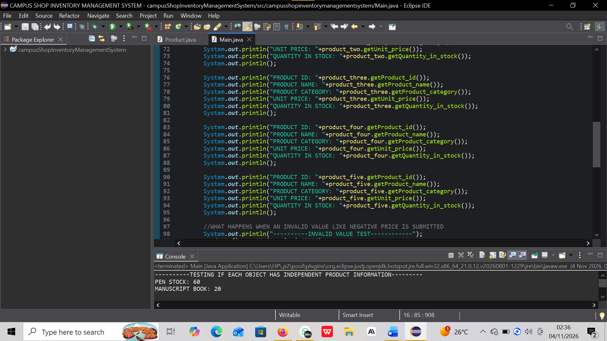

This shows the five products after updates have been made.
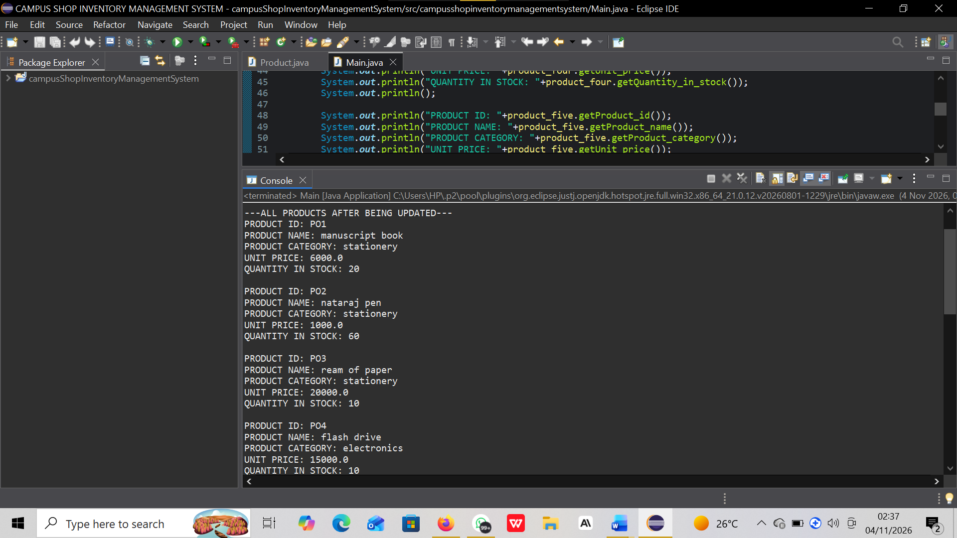

This shows the invalid test output reading the error message that it cannot be negative and then the price of the calculator that does not change.

